Course Project – Visualization Tools Comparison

Shaun Pritchard

Rasmussen College

QMB3300

Jerome Olorunmaiye

May 18, 2020

**Course Project – Visualization Tools Comparison**

*Discuss which features of the various data visualization tools closely align with the needs of the intended audience.*

I was not sure how many tools I was supposed to select so I filled up all the selection boxes in the data visualization comparison tool.

**Here is a list of the comparison of data visualization tools I selected.**

* DOMO
* Tableau
* QlikView
* Power bi
* SAS BI

After a thorough comparison of all these different technologies, I found that most of these Technologies only provision data visualization While others do that plus facilitate the means to store and transform data.

I found that Domo and Power BI checked off more features and are tools that can take raw data from sources or facilitates technology to table sources. All the way to the transformation and visualization process. These tools also have more features to work with multiple data types, integrations, management of Big Data, synchronization, data science tools, and visualization.

**Here is a list of all the features used in the comparison:**

|  |  |  |
| --- | --- | --- |
| Access Control | Active Directory Integration | Activity Tracking |
| Ad hoc Query | Ad hoc Reporting | Alerting |
| API Management | Application Integration | Application Security |
| Automatic Reminders | Big Data Management | Charting |
| Collaboration Tools | Collaborative Workspace | Custom Applications |
| Customizable Reporting | Dashboard Creation | Data Connectors |
| Data Extraction | Data Filtering | Data Import/Export |
| Data Science Tools | Data Synchronization | Data Transformation |
| Data Visualization | Data Warehousing | Drag & Drop Interface |
| Drill Down Capability | Embed | ETL |
| Federated Queries | Filtered Views | Forecasting |
| Instant Messaging | Mobile Alerts | Mobile App |
| Multiple Data Sources | Offline Access | On-Premises Deployment |
| Performance Reports | Permission Management | Predictive Analytics |
| Process Automation | Project Management | Projections |
| Real Time Notifications | Real Time Reporting | Risk Alerts |
| Role-Based Permissions | Single Sign On | SSL Security |
| Third Party Integration | Trend Analysis | Workflow Management |
| Write-back |  |  |

As far as visualization tools they all facilitated the ability to produce customized dashboards and visualizations. Also, with collaborations while applying many different types of analysis and Reporting. Such as Trend analysis, predictive Analytics, drag and drop interfaces, data science tools, data synchronization, data visualization, risk alerts, and collaboration tools.

Out of all the features I found these were the most important features in which all five of the tools I selected did support minus a few features in comparisons. they all implement the ability work with data sources and provided visualizations. The major differences for the kinds of data the amounts of data that frequency of data and the velocity of data each platform can handle loading into transformations.

***Provide a detailed explanation as to why you selected the data visualization tools in your list.***

I use a tool called business intelligence Market which is a comparison tool for business intelligence tools. They stopped the popularity ranking and platform abilities I selected the data visualization Tools listed above.

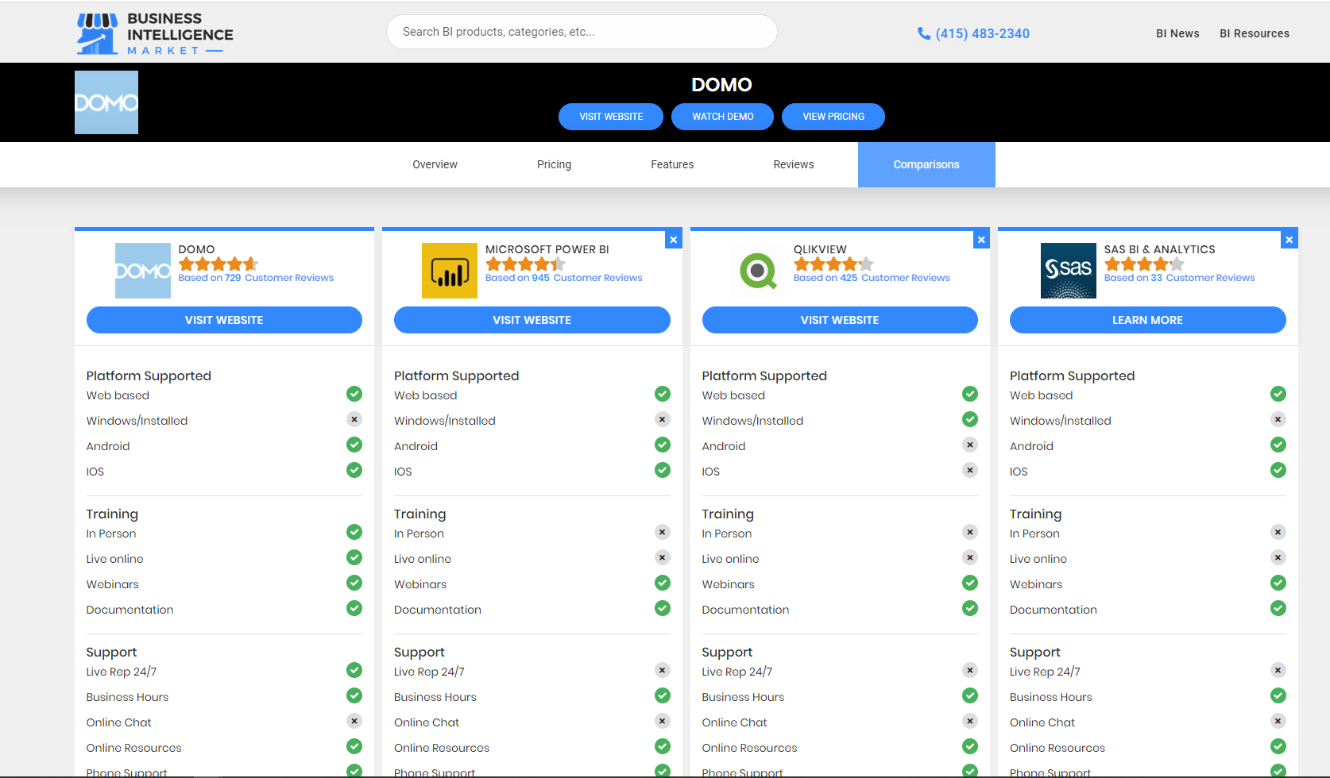

I already have some familiarity with Microsoft Power BI. I have personally used it before and have it on my desktop currently. I was really interested to learn about QlikView and Tableau. I heard a lot of good things about them. I never heard of DOMO, yet it was rated the highest and ranked the highest in the comparison charts. It also provides more features then all of the data visualization tools collectively.

These are powerful visualization tools all with different limitations and featured abilities to handle different task and allocations of projects.